Revenge is Sweet

Pirkei Avos 4:19
Samuel Hakatan would say: "When your enemy falls, do not rejoice; when he stumbles, let your heart not be gladdened. Lest G‑d see, and it will be displeasing in His eyes, and He will turn His wrath from him [to you]" (Proverbs 24:17-18).

#1
Torah, Shemos 21:23
An eye for an eye, a tooth for a tooth, a hand for a hand, a foot for a foot.

Talmud, Tractate Bava Kama 84a
One who blinds someone else's eye pays the damaged person money in proportion to the damage done.

#2
(a)
I have been seriously hurt by my ex. It has now been seven months of abuse, put-downs, bad-mouthing and humiliation, and I have remained silent. But now I have an overwhelming urge to take revenge. And I have the chance. With one phone call, I could ruin his career and shatter his entire life.
Should I do it?
(b)
Your child comes home and says: “I hate Yaakov. He embarrassed me in front of the whole class. I wish I could beat him up or embarrass him back. He deserves it!”
What should you say?

#3
Torah, Vayikra (Leviticus) 19:17, 18
Do not hate your brother in your heart. You must reprove your fellow, and do not bear a sin because of him.
Do not take revenge and do not bear a grudge against the members of your people. You must love your fellow as [you love] yourself. I am G-d.

Question: What is the message behind the ordering of the verses?

#4
Torah, Vayikra (Leviticus) 19:18
Do not take revenge and do not bear a grudge against the members of your people...

Rashi
Do not take revenge – [One man] said to [another], “Lend me your sickle,” [and the second] said to [the first], “No.” The next day [the second] said to [the first], “Lend me your axe,” [and the first] said to [the second], “I am not lending it to you, just as you did not lend me your sickle.” This is taking revenge.
And what is bearing a grudge? [One man] said to [another], “Lend me your axe,” [and the second] said to [the first], “No.” The next day [the second] said to [the first], “Lend me your sickle,” [and the first] said to [the second], “Here it is for you, and I am not [acting] like you, in that you did not lend me [your axe].” This is bearing a grudge (Gemara Yoma, 23a) [from the root Hebrew word “keeping” or “guarding”], for he keeps the enmity in his heart even though he does not take revenge.

(a)
What the second man did seems to be 100% justified. He was paying the first one back exactly measure for measure. That is just and proper.
And especially in the case of bearing a grudge - the second man is different the first one - he conquered his nature, and did not take revenge.

Questions:
Why doesn’t Torah want us to exercise justice?
Are revenge and justice the same?

(b)
Mesilas Yesharim, chapter 11
… Also hatred and revenge are very difficult for man’s spiteful heart to escape. For man feels his insults intensely, and has great pain from them.
And for him revenge is sweeter than honey, for it is his sole contentment.

Holding grudges and taking revenge are among the most primal human instincts.
Question: Why does Scripture condemn this sentiment? How does Torah expect us - plain human beings - not angels - not to want to revenge or bear a grudge?

#5
Question: What are possible positive outcomes for not revenging or bearing a grudge?

#6
Sefer HaChinuch 241
...And the root of this commandment is that a person should know and internalize that anything that happens to him, whether good or bad, its ultimate cause is from G-d…
And in addition, this commandment has a great benefit to quiet dispute and to remove enmity from people's hearts.

#7
Sefer Chofetz Chaim, Introduction, Negative Mitzvos 8, 9 in Be’er Mayim Chaim
It is correct reasoning to say that at the moment of being insulted, it is beyond the capabilities of human nature to remain [silent] like a stone which is immovable. Unless, he is someone that G-d has blessed with [unusually] holy character traits...
But after that moment, when his anger has already cooled off, the Torah prohibits him to arouse himself [again] to take revenge on him. And even to preserve the hatred in his heart is prohibited, but rather with the passing of a little time he must ensure that the matter is forgotten from his heart.

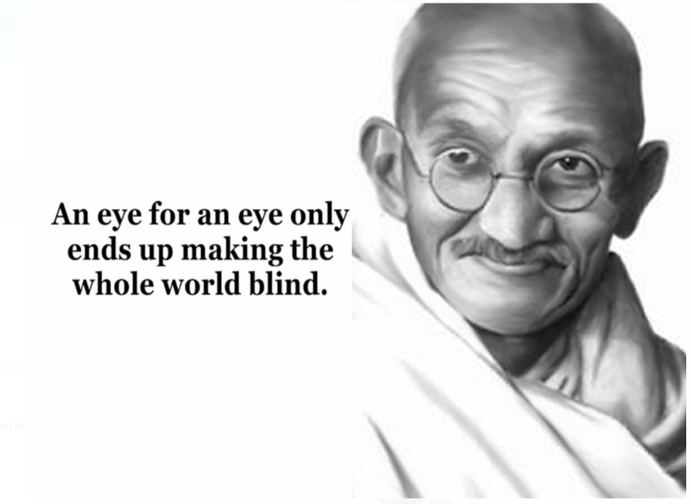

#8

Question: What is your takeaway from today’s discussion?

